ELECENG 2EI4
DP #2: Voltage Controlled Switch

Instructor: Dr Haddara
Jasmine Dosanjh – dosanj5 – 400531879
March 2, 2025
Table of Contents
Table of Figures 2
Summary 2
Test Plan 3
Non-ideality 1: When switch is ON it has an internal resistance $RON$ 3
Non-ideality 2: When switch is OFF it has a small leakage current $IOFF$ 3
Non-ideality 3: $Vmin<V1 , V2<Vmax$ 4
Non-ideality 4: When switch is ON, $RON$ remains the same with input $V1$ or $V2$ (bidirectionality). 4
Switch Type 1 5
i. Circuit Schematic 5
ii. Measurements Performed (Test Plan) 5
iii. Theoretical Explanation 6
iv. Design Tradeoffs 6
Switch Type 2 7
i. Circuit Schematic 7
ii. Measurements Performed (Test Plan) 8
iii. Theoretical Explanation 8
iv. Design Tradeoffs 8
References 10

Table of Figures
Figure 1. Switch 1 Schematic 5
Figure 2. Switch 2 Schematic 6

Summary

Test Plan
Listed below are experiments to be conducted for each non-ideality. This will identify the performance of the design.

Non-ideality 1: When switch is ON it has an internal resistance $R_{ON}$
Set Values:
- $V_{control}=0$ (to keep the switch closed)
- $V_{1}$ = 3V
- $R_{L}=4400kΩ$
Measure:
- $V_{2}$ (voltage drop across $R_{L}$)
Calculate:
- $R_{ON}$ (voltage drop across closed switch) by voltage division:
$$V_{2}=V_{1}\left(\frac{R_{L}}{R_{ON}+R_{L}}\right)$$
$$V_{2}=3V\left(\frac{1kΩ}{R_{ON}+1kΩ}\right)$$
$$R_{ON}=\frac{3V(1kΩ)}{V_{2}}-1kΩ$$

Non-ideality 2: When switch is OFF it has a small leakage current $I_{OFF}$
Set Values:
- $V_{control}=5V$ (to keep the switch open)
- $V_{1}$ = 3V
- $R_{L}=2.2MΩ$
Measure:
- $V_{2}$ (voltage drop across $R_{L}$)
- $I_{OFF}$ (current through open switch)
  - Use math channel: $I=\frac{V_{2}-V_{1}}{R_{L}}$ <-- OR TRY BOTH $I=\frac{V_{2}}{R_{L}}$

Non-ideality 3: $V_{min}<V_{1} , V_{2}<V_{max}$
Set Values:
- $V_{control}=5V$ (to keep the switch open)
- $V_{max}=5V$, $V_{min}=0V$
- $V_{1}=3V$
- $R_{L}=1kΩ$
Measure:
- $V_{1}$ (input voltage)
- $V_{2}$ (output voltage)

Non-ideality 4: When switch is ON, $R_{ON}$ remains the same with input $V_{1}$ or $V_{2}$ (bidirectionality).
Set Values:
- $V_{control}=0V$ (to keep the switch closed)
- $V_{2}=3V$
- $R_{L}=1kΩ$
Measure:
- $V_{2}$ (voltage drop across $R_{L}$)
Calculate:
- $R_{ON}$ in Direction 2 (when polarity is reversed) by voltage division:
$$V_{1}=V_{2}\left(\frac{R_{L}}{R_{ON}+R_{L}}\right)$$
$$V_{1}=3V\left(\frac{1kΩ}{R_{ON}+1kΩ}\right)$$
$$R_{ON}=\frac{3V(1kΩ)}{V_{1}}-1kΩ$$

Switch Type 1

Circuit Schematic
The circuit for switch 1 is a transmission MOSFET, with an input voltage $V_{1}$ an output voltage $V_{2}$. A load is attached to the output for testing purposes. Refer to Figure 1 for the schematic.
For the pMOS, the control voltage is applied to the gate, and the bulk is attached to the highest voltage $V_{supply}=+5V$. Whereas, for the nMOS, the supply voltage is applied to the gate, and the bulk is attached to the lowest voltage (ground).
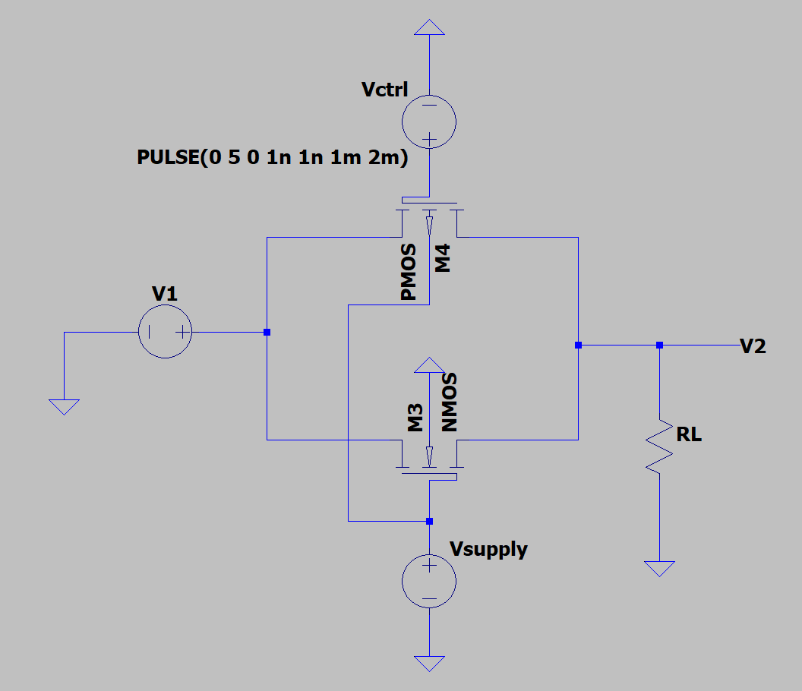
Figure 1. Switch 1 Schematic

Measurements Performed (Test Plan) -- Simulation
Non-ideality 1: When switch is ON it has an internal resistance $R_{ON}$
Set Values:
- $V_{control}=0$ (to keep the switch closed)
- $V_{1}$ = 3V
- $R_{L}=4400kΩ$
Measure:
- $V_{2}$ (voltage drop across $R_{L}$)
Calculate:
- $R_{ON}$ (voltage drop across closed switch) by voltage division:
$$R_{ON}=\frac{3V(1kΩ)}{V_{2}}-1kΩ$$
$$R_{ON}=\frac{3V(1kΩ)}{2.999V}-1kΩ$$
$$R_{ON}=0.333$$

Non-ideality 2: When switch is OFF it has a small leakage current $I_{OFF}$
Non-ideality 3: $V_{min}<V_{1} , V_{2}<V_{max}$
Non-ideality 4: When switch is ON, $R_{ON}$ remains the same with input $V_{1}$ or $V_{2}$ (bidirectionality).

Theoretical Explanation

Design Tradeoffs

Switch Type 2

Circuit Schematic
The circuit for switch 2, which is shown in.

The circuit for switch 2 is an extension of switch 1. It is a double transmission MOSFET, with the same input voltage $V_{1}$ but a separate output voltage $V_{A}$ and $V_{B}$. It also has a CMOS inverter. Once again, a load is attached to the output for testing purposes. Refer to Figure 2 for the schematic.
For the pMOS, the control voltage is applied to the gate, and the bulk is attached to the highest voltage $V_{supply}=+5V$. Whereas, for the nMOS, the supply voltage is applied to the gate, and the bulk is attached to the lowest voltage (ground).

CMOS Inverter:-
- Need $V_{control}$ and ${\overline{V}}_{control}$ (inverted).
- ${\overline{V}}_{control}$ is the output of a CMOS inverter.
Top switch:-
- This is switch 1.
- $V_{control}$ goes to pMOS gate.
- ${\overline{V}}_{control}$ goes to NMOS gate.
Bottom switch:-
- This is a duplicate of switch 1.
- The bulk is attached to the lowest voltage (ground).
- $V_{control}$ goes to nMOS gate.
- ${\overline{V}}_{control}$ goes to pMOS gate.
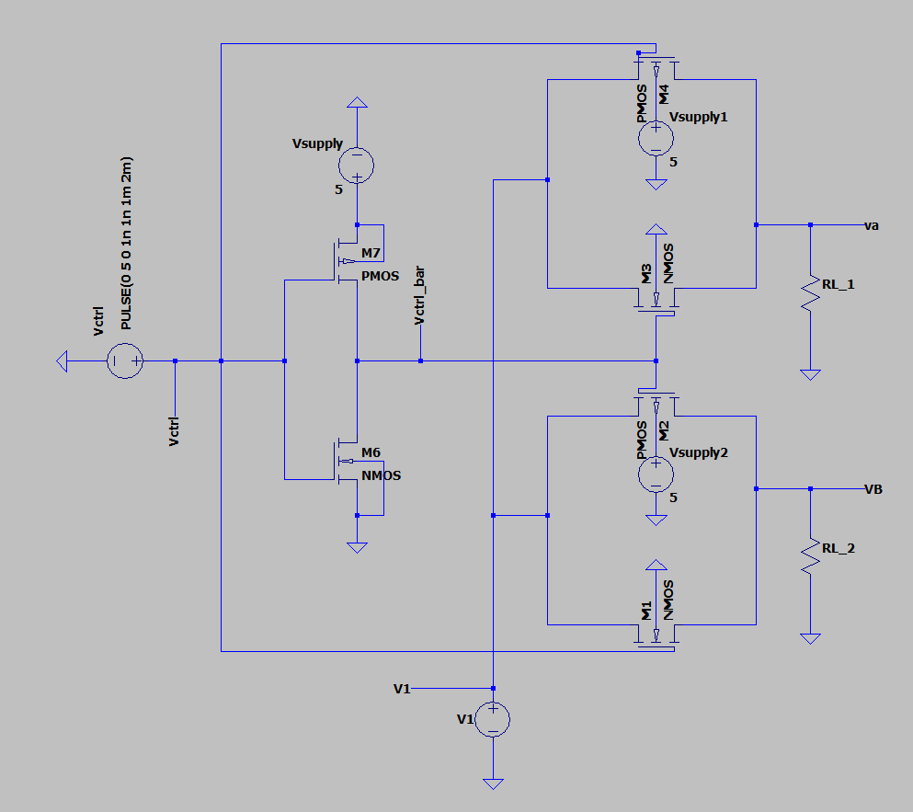
Bottom switch
Top switch
CMOS Inverter
Figure 2. Switch 2 Schematic

Measurements Performed (Test Plan)
Non-ideality 1: When switch is ON it has an internal resistance $R_{ON}$
Non-ideality 2: When switch is OFF it has a small leakage current $I_{OFF}$
Non-ideality 3: $V_{min}<V_{1} , V_{2}<V_{max}$
Non-ideality 4: When switch is ON, $R_{ON}$ remains the same with input $V_{1}$ or $V_{2}$ (bidirectionality).

Theoretical Explanation

Design Tradeoffs

References

